

Temperature and Precipitation Investigation

SUBJECT: Weather variables, climate, and graphing.

GRADE LEVEL: 3rd to 5th

DEPTH OF KNOWLEDGE LEVEL: 2 and 3

AUTHOR: Dr. Lawrence Rudd, School of Education, Nevada State College, Lawrence.rudd@nsc.edu

NEXT GENERATION SCIENCE STANDARDS:

1. Represent data in tables and various graphical displays (bar graphs and pictographs) to reveal patterns that indicate relationships. (3-ESS2-1)
2. [Obtain and combine information from books and other reliable media to explain phenomena. (3-ESS2-2)](http://www.nap.edu/openbook.php?record_id=13165&page=74)
3. [Scientists record patterns of the weather across different times and areas so that they can make predictions about what kind of weather might happen next. (3-ESS2-1)](http://www.nap.edu/openbook.php?record_id=13165&page=186)
4. [Climate describes a range of an area's typical weather conditions and the extent to which those conditions vary over years. (3-ESS2-2)](http://www.nap.edu/openbook.php?record_id=13165&page=186)

PRIOR KNOWLEDGE: Students will know how to draw and interpret graphs. Students will be familiar with weather variables and be able to define climate.

INTRODUCTORY ACTIVITY: Find definitions of weather, precipitation, and temperature in a book or from an online source. Why do you think it is important to know these two weather variables? Watch a weather forecast for the place that you live. How does the weather forecaster describe the temperature and precipitation when they give the weather forecast?

CONCEPT/SKILL DEVELOPMENT:

**Objective:**

The purpose of this investigation is to be able to read and interpret temperature and precipitation graphs. Given temperature and precipitation graphs of a site in Nevada, students will be able to compare these graphs to describe similarities and differences between these graphs and a climograph of the same site.

**Materials:**

Graphs of temperature and precipitation and a climograph from the Nevada Climate-ecohydrology Assessment Network (<http://sensor.nevada.edu/NCCP/Climate%20Monitoring/Network.aspx>).

**Important Terms:**

Precipitation

Temperature

Graph

Climograph

Climate

**Diving question:**

What information about a place can be found on temperature and precipitation graphs?

**Background Information**

Information about the weather is collected at weather stations which contain a variety of weather instruments. Two of those instruments are thermometers used to measure temperature and rain gauges to collect and measure precipitation. A series of weather stations in an area is called a transect. Two transects were created in Nevada in 2011 to collect information about the weather in the Sheep Range in southern Nevada and the Snake Range in eastern Nevada.

Data from one of the stations in the Snake Range transect was used to create the graphs you will examine in this investigation. This station is located in an area that is dominated by a plant called sagebrush, so the station is named the Sagebrush Station. While it is useful to look at individual temperature and precipitation graphs to understand the weather in a place, people who are interested in weather also create graphs that combine information on temperature and precipitation on one graph called a climograph. A climograph is used to describe the climate in a place. Climate is what the weather is like over a long period of time, at least thirty years so all of the yearly ups and downs of the weather are averaged out in a description of a location’s climate.

While you are working on the introductory activity, visit the site:

<http://sensor.nevada.edu/NCCP/Climate%20Monitoring/Equipment.aspx>

to examine both the instrumentation at each transect site as well as the location of the data transects themselves.

**Resources**

<http://sensor.nevada.edu/NCCP/Default.aspx>

The Nevada Climate Change Portal. This site explains the Nevada Climate Change project.

<http://eo.ucar.edu/webweather/basic1.html>

This site contains information on storms and weather variables such as precipitation.

<http://www.weatherwizkids.com/index.htm>

A site with lots of information about weather, including temperature, rain, and climate.

<http://www.weatherwizkids.com/weather-words.htm>

A very thorough glossary of weather terms.

**Investigation**

1. Examine the temperature and precipitation graphs (Figures 1 and 2). How are these graphs similar? How are these graphs different?
2. What type of graph is the temperature graph?
3. What type of graph is the precipitation graph?
4. Which month had the most precipitation over this 2-year period at this location?
5. Which month had the coldest average temperature over this 2-year period at this location?
6. How do graphs make it easier to understand this information? Look over the data in Table 1 before you answer this question.

**Extension**

Now that you have looked over the temperature and precipitation graphs included in this investigation, examine the climograph (Figure 3) that combines information on temperature and precipitation on one graph. Describe two ways that the temperature graph is similar to the climograph and two ways that the temperature graph is different from the climograph. Do the same for the precipitation graph. Do you find the climograph confusing or helpful?

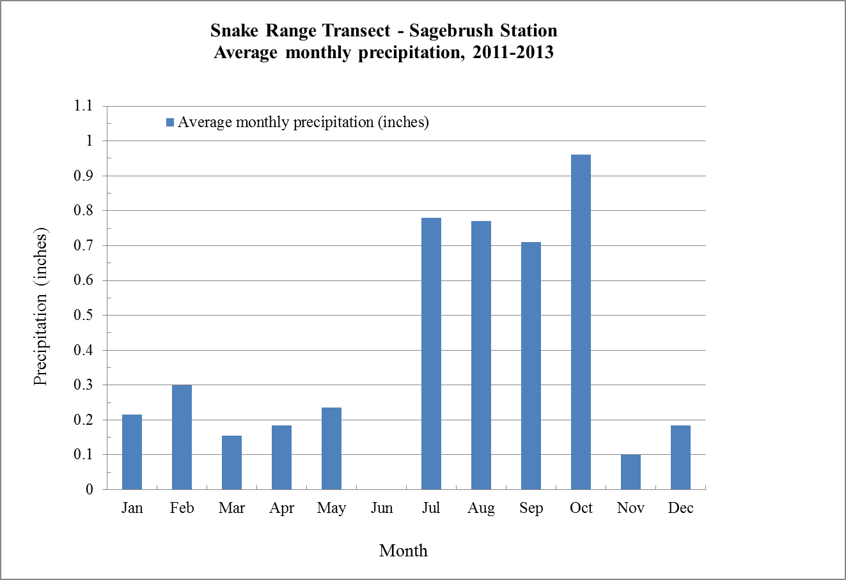

**Figure 1.** Average monthly precipitation from 2011 to 2013 at the Sagebrush Station of the Snake Range Transect, Nevada Climate-ecohydrology Assessment Network

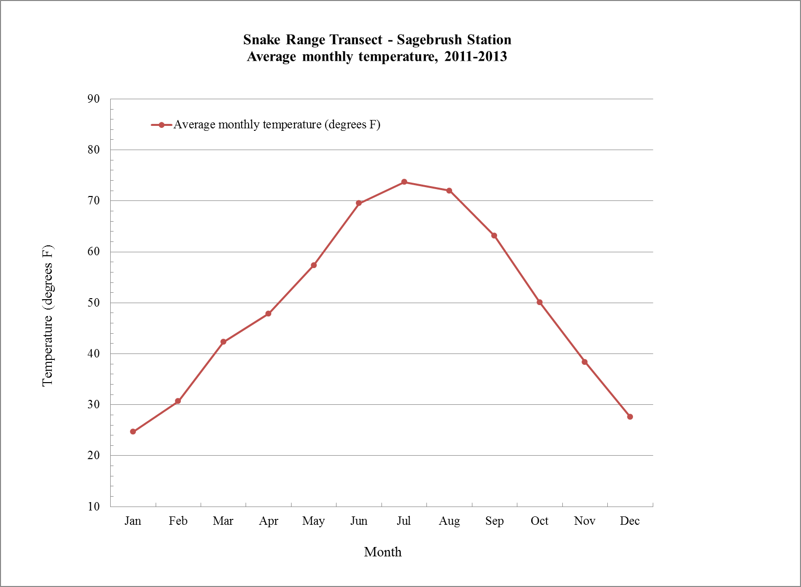

**Figure 2.** Average monthly temperatures from 2011 to 2013 at the Sagebrush Station of the Snake Range Transect, Nevada Climate-ecohydrology Assessment Network.

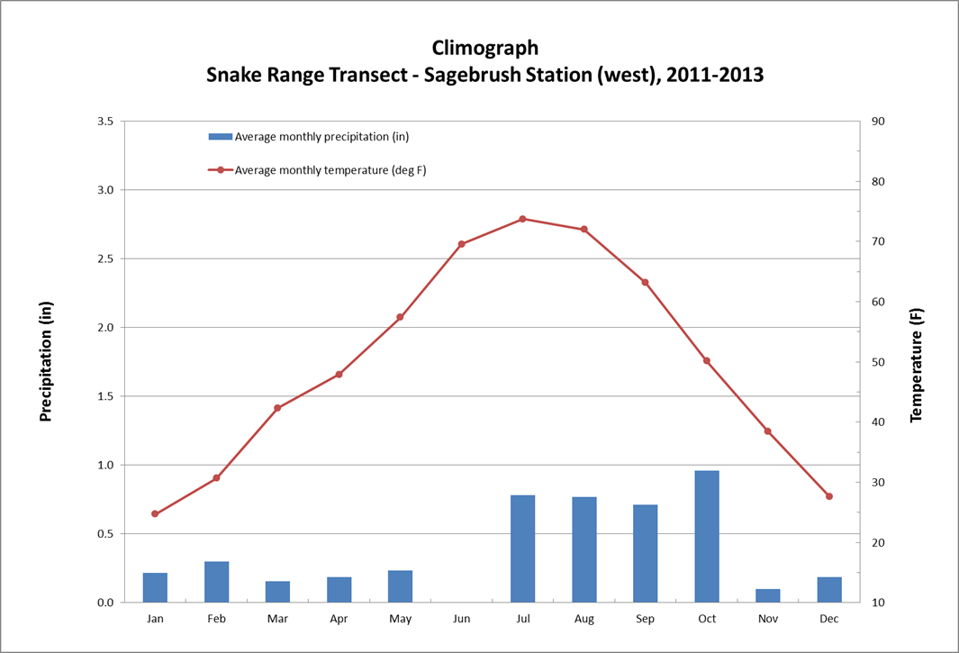

**Figure 3.** Climograph that combines precipitation and temperature readings at the Snake Range Transect, Sagebrush Station from 2011 to 2013. Data for this graph was taken from the Nevada Climate-ecohydrology Assessment Network website (<http://sensor.nevada.edu/SENSORDataSearch/>).

|  |  |  |
| --- | --- | --- |
| **Month** | **Average monthly precipitation (inches)** | **Average monthly temperature**  **(degrees F)** |
| Jan | 0.215 | 24.6775 |
| Feb | 0.3 | 30.6702 |
| Mar | 0.155 | 42.3102 |
| Apr | 0.185 | 47.8736 |
| May | 0.235 | 57.3833 |
| Jun | 0 | 69.5305 |
| Jul | 0.78 | 73.6948 |
| Aug | 0.77 | 71.9782 |
| Sep | 0.71 | 63.1496 |
| Oct | 0.96 | 50.1104 |
| Nov | 0.1 | 38.3959 |
| Dec | 0.185 | 27.63 |

**Table 1.** Average monthly precipitation and temperature from 2011 to 2013 at the Sagebrush Station

of the Snake Range Transect, Nevada Climate-ecohydrology Assessment Network.